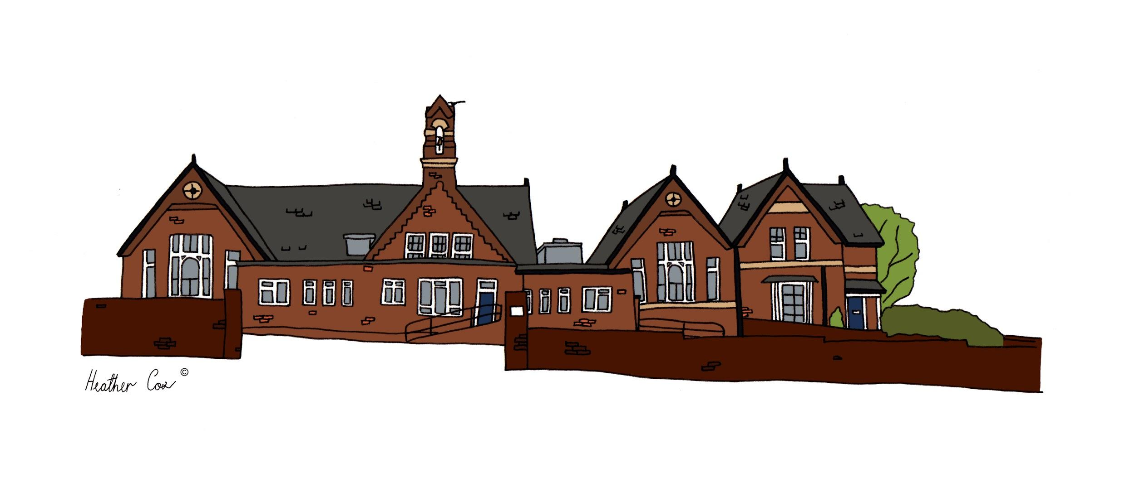
Stebbing Primary School

COVID-19
Code of Conduct

This version May 2020
Adopted June 2020
Shared with Staff and Governors May 2020

Throughout the COVID-19 pandemic and whilst on the school site, all members of the Stebbing Primary School Community will follow this extraordinary code of conduct.

All members of staff will:
- wash their hands with soap and running water every hour for 20 seconds or sanitise hands with alcohol gel.
- Sanitise their hands with alcohol gel or wash hands with soap and running water on arrival at the school, before and after eating and after sneezing or coughing.
- supervise young children when hand washing.
- clean and disinfect regularly touched surfaces frequently.
- ensure they are social distancing when possible.
- avoid physical contact with all children where possible.
- inform a member of the senior leadership team if they start to develop symptoms associated with COVID-19 (coughing, fever, runny nose, muscle pains, headaches).
- if engaging in intimate care, wear suitable PPE (gloves, apron, mouth and nose mask).
- ensure children remain in their designated teams throughout the school day.
- ensure children remain in their designated work space/at their workstation for all class based tasks.
- ensure that when outside, children remain in their designated areas.
- ensure that all doors are propped open where it is safe to do so.
- continue to follow safeguarding protocol and report any concerns immediately to a member of the senior leadership team
- report without delay any breach of the code of conduct (staff/pupils/parents).
- maintain social distancing guidelines when in the staff room or during break times.

All children will:
- clean their hands on arrival at the school, before and after eating and after sneezing or coughing.
- wash their hands every hour for 20 seconds with soap and running water.
- remain in their designated workspace/at their workstation when in the classroom.
- only go to the toilet when they have asked and permission has been granted by their teacher.
- ensure they are social distancing.
- make use of the outdoor areas in their designated area and time slots.
- avoid physical contact with all children and members of staff where possible.
- inform a member of staff if they start to develop symptoms associated with COVID-19 (coughing, fever, runny nose).
- cover their mouth and nose with a tissue or their sleeve when they sneeze or cough.
- only use the resources and equipment on their desk unless given permission to do so by a member of staff.
- take notice of the signage around the school.

All family members will:
- abide by the collection rules outlined below:
  - ensure social distancing guidelines are maintained during collection and drop off.
  - collect and drop off during the designated time slots:

Year group | Drop off time
Year 6 | 8.45am (opening on 3rd June)
Year 1 | 8.55am (opening on 2nd June)
Reception | 9.05am (opening on 2nd June)

Year group | Pick up time
Reception | 2.30pm (except Friday 12.35pm)
Year 1 | 2.40pm (except Friday 12.45pm)
Year 6 | 2.50pm (except Friday 12.55pm)

  - use the appropriate entrance and exit to minimise contact.
- only enter the school building when given permission to by a member of staff.
- ensure only ONE family member accompanies the child at drop off and for pick up.
- communicate with teachers via email or telephone.
- remind your child/children of the code of conduct and explain its importance regularly.
- ensure your child is aware of what school will look like by reading the Guide to returning to Stebbing Primary, watching to video Go-Go and Gee-Jay return to school (soon to be shared), sharing the social story and other key information shared by school staff
- maintain good levels of hand hygiene.
- inform the school if you or any family member develops any symptoms associated with COVID-19.
- wash their hands every hour for 20 seconds with soap and running water.
- enure your child wears clean, washed clothes each day to school
- ensure your child brings a named water bottle to school each day
- ensure your child has suncream applied before coming to school

All visitors will:
- During the COVID-19 pandemic, no visitors will be permitted into the school building unless absolutely essential.

All contractors will:
- telephone the school office (01371 856260) on arrival and wait in the playground at the designated zone to be met by a member of the office staff.
- if they need to enter the school building, they are to be given our contractors code of conduct upon signing in (which will be done by the office staff).
- when in the school building, all contractors are to wash their hands thoroughly for 20 seconds with soap and running water.
- only enter areas of the school that are required to be entered.
- adhere to social distancing guidelines at all times.

All volunteers will:
- During the COVID-19 pandemic, no volunteers will be permitted into the school building unless absolutely essential.

Appendix and useful links

I sign to say I agree to adhere to the Code of Conduct.

If a parent of a child at Stebbing Primary, I will work with my child to ensure they adhere to the Code of Conduct. I understand that persistent, deliberate failure to comply will result in my child being asked to stay at home during the pandemic.

Please circle all that apply

Parent Child Staff Governor

Name of child…………………………………………………….. Child’s class…………………………………………..

Your name ………………………………………………..

Date……………………………………………………………….

