SEND@Stebbing
Newsletter
December 2024

Information from Essex - Specialist Healthcare Tasks
Dear Parent Carer,

Essex County Council is reviewing the current service offer for Specialist Healthcare Tasks (SHT). SHT is also referred to as delegated healthcare tasks and is the delegation of specialist healthcare tasks to non-health qualified staff working with children and young people up to the age of 19. Some of these tasks may include administration of medication and enteral feeding for example.

Staff members who have performed these tasks on your children and young people have received training and sign off from Nurses through the SHT contract which is provided by Provide Community CIC.

To help us understand the impact of the service, we are seeking the views of parent carers of children and young people whose children/young person’s currently or have previously accessed specialist healthcare tasks through Social Care settings (such as Overnight Short breaks and foster carers), Short Breaks Community Clubs and Activities, Early Years, Educational or Post 16 settings (i.e. Colleges) and/or Education transport.

We are also interested to hear from parent carers who have children or young people with specialist healthcare needs who are not accessing any of the above provision because their needs cannot be met in that setting.

Professionals supporting families are also welcome to provide their views. Please fill out this quick online survey which should take around 10 minutes to complete and helps us in the development of the service.

If you have any questions, please contact shortbreaks@essex.gov.uk. Thank you for your support.

Kind regards,
Essex SEND Short Breaks
Email: shortbreaks@essex.gov.uk
Website: http://shortbreaks.essex.gov.uk/
Facebook: www.facebook.com/ShortBreaksECC

Essex Frontline - A fantastic services directory
Frontline is a community project. It helps frontline workers and the public to quickly find details on local health and wellbeing services and to contact services through call back and referral options.
You can access Frontline here: Frontline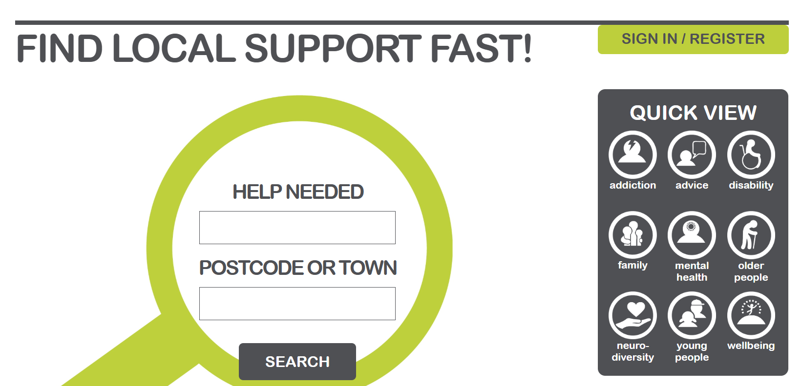
Essex Local Offer Survey - Chance to win £100!
We have been sent the following survey aimed at children with special educational needs or disabilities aged 10 and over. Please help your child to complete the survey regarding the Essex Local Offer: Supporting your dreams and goals for the future

Happy Hill has re-opened in new premises
Happy Hill offers a wide range of hub-based sessions. Their fun-filled activity clubs focus on emotional and social growth, enabling children with SEND to play, grow, and feel empowered. They offer lots of exciting trips and activities, both in their hall, out in the community, and in their minibus. Happy Hill offers holiday clubs, Saturday clubs and Stay and Play sessions. New events are planned for the new year.
To access Happy Hill you will need to meet the criteria for a Short Breaks Passport ID which can be applied for here:
Essex Short Breaks

Snap Charity supporting children with SEND

If you have a child between 0 – 25 years who has any additional need or disability and you live under Essex County Council, Thurrock or Southend local authorities then Snap is here for you and your family. No formal diagnosis or professional referral is necessary to access SNAP services.

Enter the SNAP charity here.
SEND Family Forums
Each half term, the school hosts a forum for parents, carers, and other family members. All families are welcome to attend, regardless of whether your child has an identified special need or disability. The forum is a great opportunity to learn more about the support available at Stebbing and to connect with other families who may share similar experiences. Occasionally, we also offer workshops during these sessions, led by school staff or guest speakers.
Here’s a reminder of the SEND Family Forum dates for the rest of this year:
- Monday 13th of January at 9am
- Thursday 6th of March at 2pm
- Monday 28th April at 9am
- Wednesday 25th of June at 2pm
SEND Family Consultations - One Plan reviews
For children with One Plans, the school will continue holding our termly SEND Consultations to review their progress. It’s helpful if you can attend your child’s Consultation on the scheduled dates, as this allows staff to promptly set new targets and put new provisions in place at the start of each term.
Here’s a reminder of the meeting dates this year:
- Wednesday 17th of January from 3.15pm
- Wednesday 30th of April from 3.15pm
- Wednesday 9th of July from 3.15pm

Invitations to sign up for a consultation slot will be sent to relevant families via Arbor shortly before the scheduled dates. Thank you for your support with this important part of your child’s educational provision.

