SEND@Stebbing
Newsletter - April 2025

Parent-4-Parent Support Group
Parent4Parent is a parent and carer support group for those whose children (aged 0-25) have social communication difficulties (with or without any diagnosis) or who experience difficulties coping with interaction and the social world. We aim to address the isolation that parents and carers often feel over a welcoming tea or coffee.
We share experiences and swap tips in a confidential space. We occasionally invite relevant people to come and talk with us about different kinds of needs and how to help. Please also see the details for the dedicated Facebook page - Parent4Parent (P4P) Dunmow or follow the link for more information: Parent-4-Parent full details
The next Parent-4-Parent session is on:
Date and time
Friday 9th of May
10am to 12pm
Address
Takeley Old School Community Hub, Dunmow Rd, Takeley, CM22 6OJ
Essex Autism Support Offer
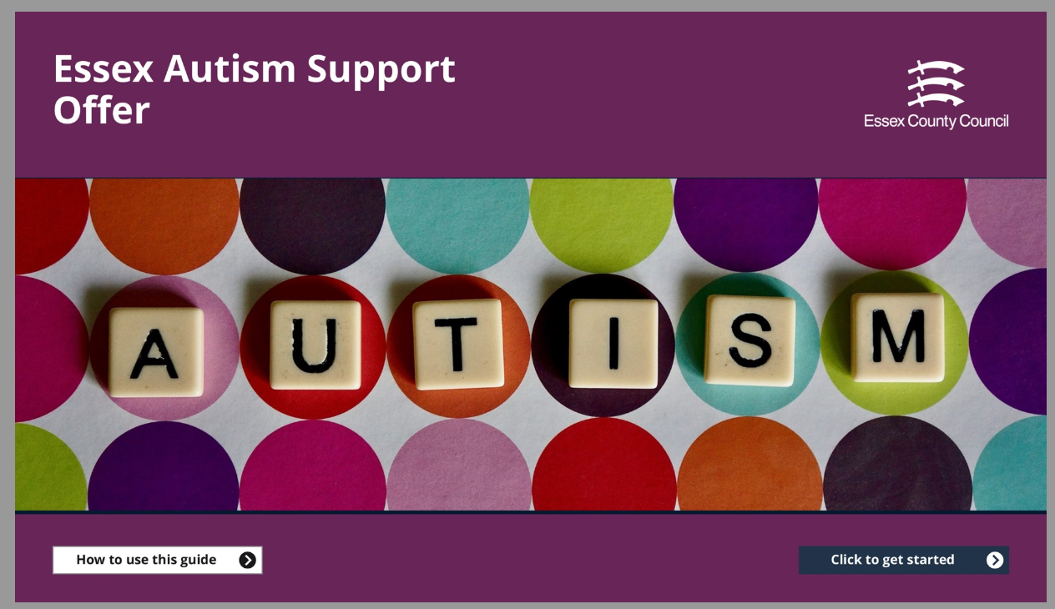
This is a comprehensive interactive booklet designed by the ECC SEND strategy and innovation team. The purpose of the resource is to set out Essex’s support for the autistic community. It also has links to support and training for parents.
Autism Update - 1

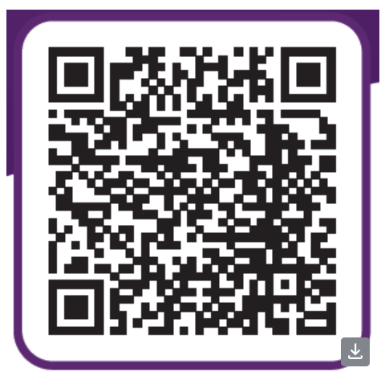
NEW Directory of Services
Visit the directory here:
Find support services for children and their families | Essex County Council

We are thrilled to inform you that the NEW Directory of Services has been launched on the ECC website.
The original Directory has been thoroughly audited with only current family focussed services now included.
This digital solution has been designed after user testing to ensure that it is easy to navigate and there will be further user testing 3 months’ after launch.
There is also a button on the front screen to suggest an edit to a listing or add a new service which C&F Hub staff will regularly action. Do give it a try!

Essex Local Offer Roadshows
The Essex Local Offer SEND Roadshows are taking place across Essex in March. These are an opportunity for parents and carers of children and young people with SEND to come along and ask a variety of services and organisations any questions about SEND. The event is free and no booking is required (unless parents want to access one of the free workshops).
More information about the roadshows can be found by following this link Essex Local Offer Roadshows.

The next West Essex Roadshow is:
Date and time
Thursday 26 June 2025
9.30am to 12.30pm
Address
Zinc Arts, Great Stony, High Street, Chipping Ongar, CM5 0AD

